Can Unamendable Term Limits Prevent Presidents-For-Life?

David Crabtree
University of Chicago
Chicago IL
United States
July 2025

Abstract
Since 1990, one in six presidents have attempted to prolong their time in office by altering their term limits. Most often, presidents circumvent term limits by amending their country’s constitution. For this reason, some countries have incorporated language into their constitutions barring amendments to term limit provisions. Does insulating term limits in this way serve as a meaningful constraint on presidents, or do they find other ways to stay in office? Leveraging a new dataset of countries with unamendable term limits from 1789-2023, I find these restrictions may be a more effective deterrent than previously thought. Most importantly, I find that unamendable term limits appear almost exclusively in countries where presidents have violated their constitutions without consequence, and, unsurprisingly, protection provisions have rarely deterred this subset of presidents. This underappreciated dynamic means that we have likely been underestimating their potential for deterrence. Moreover, I argue that presidents’ preferred strategy for altering term limits – legislative amendment – requires less coordination and less risk than relying on courts or constituent assemblies, which presidents must turn to when amendments are blocked. Finally, even when presidents succeed at altering protected term limits, they rarely remove the term limit entirely, suggesting protections may be efficacious.

Keywords term limits, constitutions, militant democracy, autocratization, presidentialism, Latin America
Word Count 10878 (includes tables, figure captions, references)

Introduction
In presidential systems, constitutional designers establish term limits to prevent presidents from staying in power for life. Most presidents, in both democratic and non-democratic countries, are constitutionally required to surrender office after two terms. Despite their intended purpose, term limits have often failed to restrain ambitious presidents. Indeed, one in six presidents in the past thirty years have attempted, often more than once, to alter their term limits. Figure 1 illustrates which countries have experienced this phenomenon and how often. The overwhelming majority of presidential attempts to alter term limits, 73%, succeed.
Some countries responded to this wave of term limit evasion by banning constitutional amendments to term limits, hoping presidents would have a difficult time staying in office if they cannot change the law. An example is El Salvador’s constitution, which reads, “the articles of this constitution referring … to alternation in the exercise of the presidency of the republic cannot be reformed under any circumstances” (Article 348). Does banning changes to term limits deter presidents, or do they find other ways to stay in power even when term limits are protected from amendment?
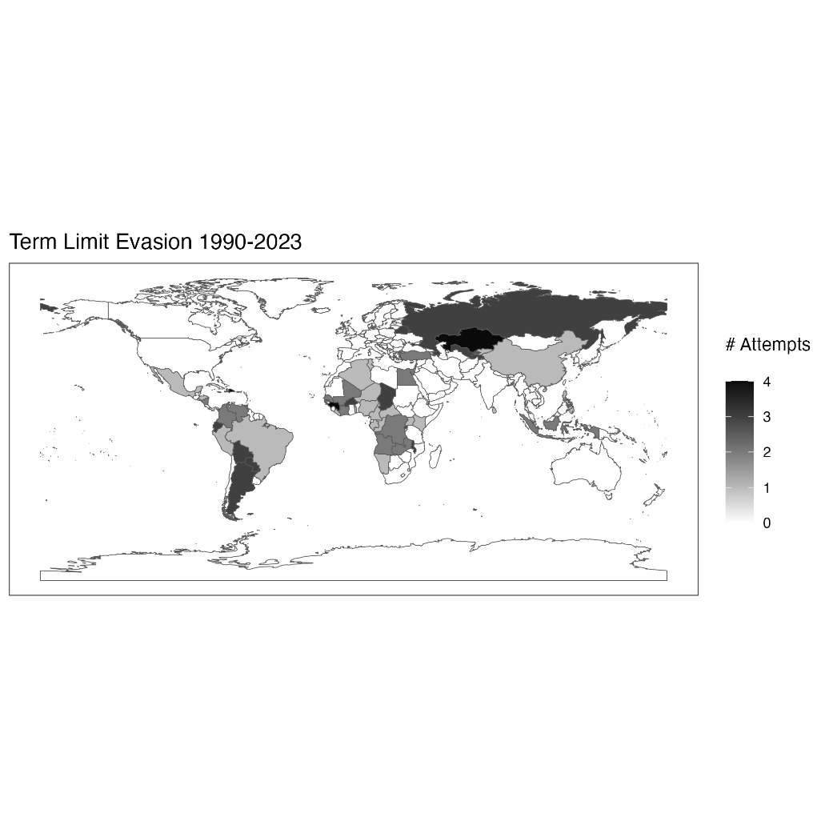
Scholars have been reticent to recommend these protection provisions as a cure for term limit evasion. Their concern centers on the other strategies, beyond amendment, that are available to presidents. If amendments are banned, presidents may just rally supporters to write a new constitution. As Elkins recently put it, “do the limits serve to deter evasion, or do leaders simply replace the constitution instead of amending it, in which case the drafters’ resolution of ‘never again’ feels like last year’s New Year’s resolution.” In fact, some even suggest unamendable term limits could encourage presidential power grabs. By forcing presidents to adopt wholesale, instead of piecemeal, constitutional change, presidents can use a new constitution to simultaneously extend their tenure and expand control over the military, the legislature, or civil society. Dixon and Landau worry “[w]riting new constitutions may achieve several goals for incumbents. First, the new constitutional text often contains a more permissive term limit than the old one . . . [additionally], constitution-making may allow presidents to make a number of changes to the powers of the president and to the structure of accountability institutions at the same time, which may allow them to consolidate power quickly.”
It is understandable why scholars have been skeptical that these provisions deter term limit evasion. Many presidents successfully thwart protected term limits. Nayib Bukele in El Salvador, Juan Orlando Hernandez in Honduras, and Paul Kagame in Rwanda have all stayed in office despite their constitutions’ protected term limit provisions. Consequently, based on available case evidence, scholars often conclude that such protections do not pose a sufficient obstacle to aspiring autocrats. A president sufficiently committed to staying in power, they reason, will find other means of maintaining control, even when amending the constitution proves insurmountable.
While such pessimism is understandable, it is likely over-exaggerated. For one, it assumes that the presidents with protected term limits are similar to the presidents with unprotected term limits. I show this is not true with a new global dataset on protected term limits from 1990-2023. Presidents with protected term limits, like Bukele, Hernandez, and Kagame, often possess an outsized capacity to pack the courts, replace the constitution, and thwart constitutional rules to remain in power. I call these presidents “high-capacity” because they can violate their constitutions with impunity. Using a proxy for this concept, I find that as many as four in five presidents with protected term limits have an outsized capacity for thwarting constitutional rules without consequence, while only two in five presidents in the general population have this capacity. Consequently, when evaluating the efficacy of protected term limits, we must assess whether weaker leaders with less capacity would so easily circumvent them. Future work should be attentive to the relationship between presidential capacity and the adoption of protected term limits, as it confounds their efficacy at deterring evasion.
Second, scholarship often treats different strategies for constitutional change as equally viable to presidents. To be sure, the individual circumstances of every case complicate attempts to generalize about the costs of various strategies for constitutional change. But I show there are good reasons to believe that amendments require notably less coordination with other political actors and involve less risk than relying on courts or constituent assemblies. As a result, banning amendments increases the difficulty and risk presidents face to successfully thwart term limits. This is true even if these presidents ultimately succeed at staying in power.
Lastly, I provide new evidence that presidents with protected term limits behave differently when attempting to stay in power. When amendments to term limits are banned, these presidents find other ways to incorporate the legislature in the process of circumventing term limits. In these cases, legislatures often legitimate the actions of courts or citizen assemblies at higher rates than in cases where legislatures can act unilaterally to amend the term limit provision. Additionally, I show that when term limits are protected, presidents are much less likely to attempt to remove the term limit entirely rather than simply altering it to allow for, say, one additional term.
Taken together, these findings challenge the literature’s assumption that protections for term limits are ineffective. If protections were adopted among a wider sample of presidents, rather than only among those presidents with track records of thwarting constitutional rules, there are good reasons to believe these provisions could deter term limit evasion. The paper proceeds as follows. First, I introduce features of the new global dataset of protected term limits. Second, I show that protected term limits are most common in areas where presidents can disrespect constitutional rules without consequence. I then theorize why we should nonetheless believe protections are effective, and the following section provides evidence that presidents with protected term limits behave differently than presidents without protected term limits when trying to stay in office. Lastly, I provide a comparison of Honduran presidents Manuel Zelaya and Juan Orlando Hernandez to emphasize the necessity of coordination among elites when term limits are unamendable. I conclude with implications for the literature and avenues for future research.

Global Dataset of Protected Term Limits
I define a protection for presidential term limits as a constitutional provision that either outright bans changes to the term limit or creates special procedures for changing the term limit. I identified 39 distinct instances of unamendable term limits in national constitutions since 1789, occurring across 29 countries, all in Latin America and Africa (see Figure 2). As detailed in Table 1, we can describe protected term limits in terms of the type of protection they offer, the year they first appeared in a country’s Constitution, the process by which they were adopted, and if applicable, the year the protections were eliminated and the process by which they were removed. Although general unamendable provisions have long received scholarly attention, work discussing provisions that specifically protect presidential term limits appears more recently. Notably, this dataset substantially expands upon Elkins’ count of 19 countries and provides information on how the protection provisions were adopted and removed.
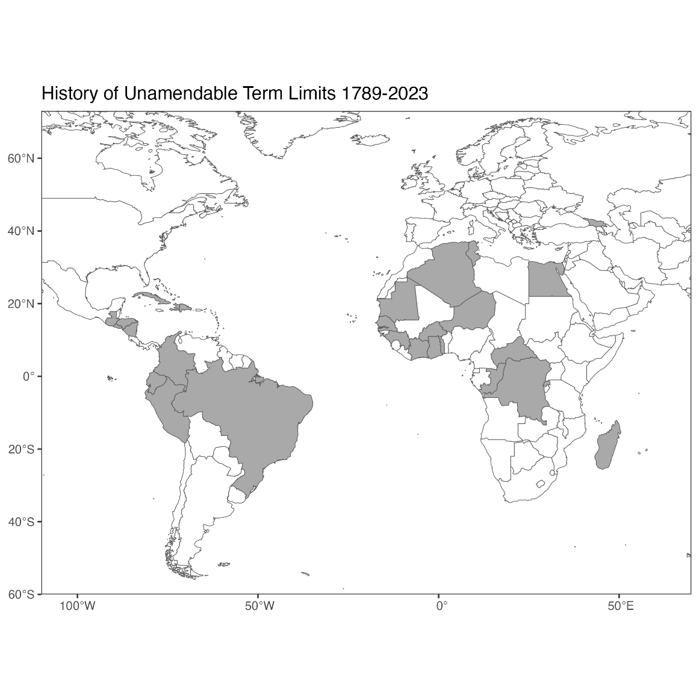
Country | Type of Protection | Start | End | Years | Protections Introduced By | Protections Removed By
Algeria | Prohibits Amendment | 2020 | —— | 3 | New Constitution
Brazil | Special Procedure | 1934 | 1937 | 3 | New Constitution | New Constitution
Burkina Faso | Prohibits Amendment | 2014 | —— | 9 | Amendment
Central African Rep | Prohibits Amendment | 1981 | 1994 | 13 | New Constitution | New Constitution
Central African Rep | Prohibits Amendment | 2004 | —— | 19 | New Constitution
Colombia | Prohibits Amendment | 1840 | 1843 | 3 | Amendment | New Constitution
Congo | Prohibits Amendment | 1992 | 2015 | 23 | New Constitution | New Constitution
Cote d’Ivoire | Special Procedure | 2000 | 2016 | 16 | New Constitution | New Constitution
Cuba | Special Procedure | 2019 | —— | 4 | New Constitution
Dem. Rep. of Congo | Prohibits Amendment | 2005 | —— | 18 | New Constitution
Dominican Republic | Presidency Must be “alternative” | 1866 | 1868 | 2 | New Constitution | New Constitution
Dominican Republic | Only Permits Prospective Changes | 1878 | 1907 | 29 | New Constitution | New Constitution
Dominican Republic | Only Permits Prospective Changes | 1908 | 1927 | 19 | New Constitution | New Constitution
Ecuador | Presidency Must be “alternative” | 1851 | 1852 | 1 | New Constitution | New Constitution
Ecuador | Presidency Must be “alternative” | 1869 | 1878 | 9 | New Constitution | New Constitution
Egypt | Amendment to Term Limits Allowed Only if it “brings more guarantees” | 2019 | —— | 4 | Amendment
El Salvador | Prohibits Amendment | 1886 | 1948 | 62 | New Constitution | Amendment
El Salvador | Prohibits Amendment | 1983 | —— | 40 | New Constitution
Gambia | Special Procedure | 2019 | —— | 4 | New Constitution
Georgia | Presidency Must be “alternative” | 1992 | 1995 | 3 | New Constitution | New Constitution
Ghana | Special Procedure | 1969 | 1981 | 12 | New Constitution | New Constitution
Ghana | Special Procedure | 1992 | —— | 31 | New Constitution
Guatemala | Prohibits Amendment | 1945 | 1954 | 9 | New Constitution | New Constitution
Guatemala | Special Procedure | 1956 | 1982 | 26 | New Constitution | New Constitution
Guatemala | Prohibits Amendment | 1985 | —— | 38 | New Constitution
Guinea | Prohibits Amendment | 2010 | —— | 13 | New Constitution
Haiti | Only Permits Prospective Changes | 1987 | —— | 36 | New Constitution
Honduras | Prohibits Amendment | 1957 | —— | 66 | New Constitution
Madagascar | Prohibits Amendment | 2010 | —— | 13 | New Constitution
Mauritania | Prohibits Amendment | 2006 | —— | 17 | Amendment
Nicaragua | Only Permits Prospective Changes | 1893 | 1905 | 12 | New Constitution | New Constitution
Niger | Prohibits Amendment | 1999 | 2009 | 10 | New Constitution | New Constitution
Niger | Prohibits Amendment | 2010 | —— | 13 | New Constitution
Peru | Prohibits Amendment | 1933 | 1979 | 46 | New Constitution | New Constitution
Rwanda | Special Procedure | 2003 | —— | 20 | New Constitution
Senegal | Special Procedure | 2001 | —— | 22 | New Constitution
Togo | Special Procedure | 2019 | —— | 4 | Amendment
Tunisia | Prohibits Amendment | 2014 | —— | 9 | New Constitution

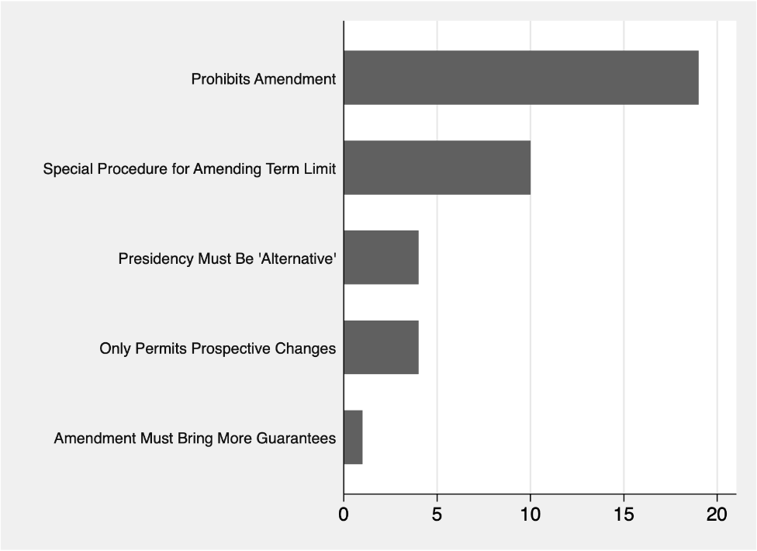
Figure 3 illustrates significant variation in the exact constitutional language of protection provisions. Some provisions protect the specific articles that limit presidential tenure, others protect the principle of term limits, some protect both, and still others restrict the time or manner for changing term limits. Lastly, some provisions, like Dominican Republic 1866, referenced in Table 2, simply specify that the exercise of the presidency must remain “alternative.” These provisions, common in 19th and 20th century constitutions, may seem to be generic and lack meaning compared to the more specific protections common today. However, scholars have generally considered “alternation” (alternabilidad and alternativo) to refer specifically to limits on presidential reelection (IE, term limits). As such, I count as protections those provisions that prevent changes to the principle of presidential alternation. The historical development of these provisions is an avenue for future research.
Table 2 provides examples of the different kinds of protections Constitutions provide to Presidential term limits.
Table 2: Types of Constitutional Protections for Term Limits, 1789-2023

Type | Subtype | Freq | Ex Citation | Ex Language
Prohibits Amendments | Protects the Idea of Term Limits | 11 | El Salvador 1983 Art 248 | “Under no circumstances, may the articles of this Constitution, which refer to . . . the principle that a President cannot succeed himself, be amended.”
 | Protects Term Limit Articles | 6 | Niger 2010 Art 175 | “. . . [t]he provisions of paragraphs 1 and 2 of Article 47 [term limit] . . . of this Constitution may not be made the object of any revision.”
 | Protects the Idea & Articles | 3 | Guatemala 1985 Art 281 | “In no case may Articles . . . 187 [term limit] be reformed, nor may any question concerning the republican form of government, or to the principle of the non-reelection for the exercise of the presidency of the Republic, be raised in any form, neither may the effectiveness or application of the Articles that provide for alternating tenure of the Presidency of the Republic be suspended or their content changed or modified in any other way.”
Special Procedure for Amending Term Limit |  | 10 | Rwanda 2015 Art 175 | “. . . However, if the amendment concerns the term of the office of the President of the Republic . . . the amendment must be passed by referendum, after adoption by each Chamber of Parliament.”
Only Permits Prospective Changes |  | 4 | Haiti 1987 Art 284 | “The amendment passed may enter into effect only after installation of the next elected President. In no case may the President under the Government that approved the amendment benefit from any advantages deriving there from.”
Presidency Must Be “Alternative” |  | 4 | Dominican Republic 1866 Art 103 | “Congress’ power to reform the Constitution does not extend to the form of government, which will always be republican, democratic, alternative, and responsible.”
Amendment Must Bring More Guarantees |  | 1 | Egypt 2019 Art 226 | “In all cases, texts pertaining to the re-election of the president of the republic . . . may not be amended, unless the amendment brings more guarantees.”
I combine this data on constitutional protections with data on presidential attempts to overcome term limits. I expanded and disaggregated Versteeg et al’s (2020) term limit evasion data, which defines an instance of term limit evasion as a legal attempt to circumvent term limits. Attempts are counted even if they fail. Failed attempts occur when there is a clear effort to alter the language or interpretation of term limits which ultimately are unsuccessful. For instance, to classify a failed legislative attempt, a draft of an amendment altering the presidential term must fail. This coding choice likely underestimates the incidence of presidential efforts to amend term limits, because many such attempts may falter before a draft amendment is produced. This is also true for other efforts to circumvent term limits via courts or constitutional replacement. Successful term limit evasions are coded as such when they result in legal changes that alter the language or interpretation of the constitution’s term limit provision.

Problems in Estimating the Effect of Protected Term Limits

Do constitutions that protect term limits deter presidents from staying in office for life? Skeptical scholars point to prominent cases where presidents have overcome unamendable term limits. Juan Orlando Hernandez in Honduras and Nayib Bukele in El Salvador are prominent examples of presidents overcoming protected limits. However, skeptics overlook an important confounding factor. The presidents who have been barred from amending their term limits are often those that can get away with altering or violating their constitutions without consequence. I provide evidence for this confounding variable, which I label presidential capacity for enacting constitutional change with impunity, and I show that this confounding limits our ability to make definitive inferences about the efficacy of unamendable term limits.
Institutions are often established as a strategic response to behavior. In the case of protections for term limits, they were adopted in places with long histories of dictatorial rule, where leaders frequently disregard or alter constitutions that are inconvenient for them. El Salvador and Honduras have some of the strictest protections for term limits in the world, both including provisions threatening the revocation of citizenship and public office for even proposing changes to the term limit provision. Both countries also have histories of strong presidents and harsh dictatorships. In El Salvador, General Maximilano Hernandez Martinez came to power in the 1930s and was responsible for the deaths of nearly 4% of El Salvador’s population in 1932; Martinez was the longest serving Salvadoran president, overcoming the oldest protected term limit regime in the world. Is there a more general correlation between presidential strength and term limit protections?
Table 3: Presidential Strength & Protected Term Limits
 | No Protections for Term Limits | Protections for Term Limits
Presidents rarely or never violate the Constitution (Low-Capacity) | 236 | 16 | 252
Presidents violate Constitution whenever they want, can violate most provisions without consequence, or some provisions without consequence (High-Capacity) | 131 | 59 | 190
 | 367 | 75 | 442
I used V-Dem’s estimate of whether a country’s executive respects the constitution (v2exrescon), where I coded a president as high capacity if they could “violate the constitution whenever they want,” “violate most provisions without legal consequences,” or “face legal consequences for violating most provisions, but can violate some without any consequences,” and I coded a president as low capacity if they “rarely violate the constitution, and when it happens face legal charges” or “never violate the constitution”.
Between 1990-2023, only 21% (16/75) of the presidents who had protected term limits had a low capacity for thwarting constitutional rules with impunity, while all other presidents with protected term limits had a high capacity for this behavior. This difference is significant (p < 0.001; see Table 3 and Figure 5 for a cross-tab and visual comparison). . In other words, protected term limits have rarely coincided with presidents of low capacity for constitutional change. The vast majority of presidents with protected term limits are high capacity. These presidents are precisely those best equipped to overcome the additional barrier that protections pose. This leads us to underestimate the true deterrent effect of protected term limits.

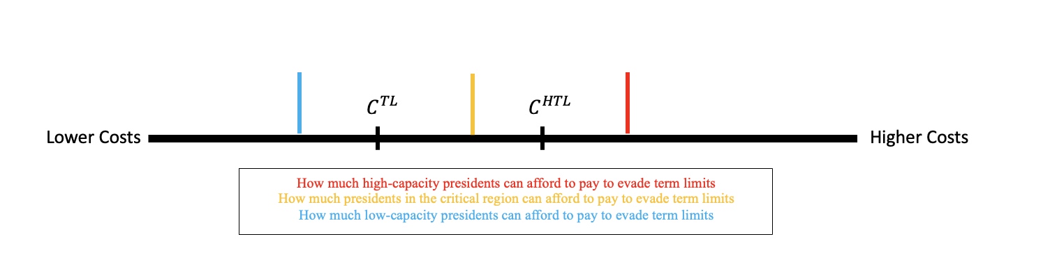
This confounding limits our ability to estimate the effectiveness of term limit protections. Figure 4 illustrates how protections could deter term limit evasion without the effect being detectable in the current sample. It theorizes the costs, C, of high-capacity versus low-capacity presidents under regular term limits, TL, versus hardened term limits, HTL. The red and blue lines indicate how much high- and low-capacity presidents, respectively, are able to ‘pay’ to commit term limit evasion. The Figure assumes it is true that HTL impose higher costs than TL for both high- and low-capacity presidents, but high-capacity presidents can overcome even HTL anyway. The implication is that, in a world like ours where high-capacity presidents with HTL are prevalent, examining evasion outcomes will show that protections have no effect, even if they really do, because we only observe a particular subset of all presidents. If many presidents outside the sample are in the critical region, where their power is sufficient for overcoming unprotected term limits but insufficient for overcoming protected term limits, then we would be unknowingly underestimating the power of these provisions to stop term limit evasion. Merely comparing evasion rates in cases of TL versus HTL does not categorically exclude the possibility that HTL can be effective. Existing case studies concluding that protections are impotent deserve greater caution considering the strong relationship between protections and high-capacity presidents.
One might conclude from this finding that we should control for presidential strength and estimate the effect of protected term limits on term limit evasion. However, this is inadvisable, at least with the data presented in this paper. There is not enough variation among presidents with protected term limits: they are almost all high-capacity. Only 16 presidents with protected term limits in the last three decades have been low-capacity. Consequently, tests with this control would be underpowered to detect effects even if they existed. Resultantly, we lack concrete understanding of whether protections are effective in cases where presidents are less adept at altering the constitution. Future research may consider data before 1990. Were presidents with term limit protections in earlier decades less capable of altering their constitutions with impunity? If so, then a larger dataset controlling for this capacity effect may come closer to estimating the effect of protections on term limit evasion.
In sum, if we only judge hardened term limits by whether or not they prevent term limit evasion, particularly in cases where data is available, we will be almost certain to conclude that they fail. But as Figure 4 illustrated, these results do not rule out the possibility that protections are effective; we may simply be unable to detect an effect in the current sample. Because it is unfeasible to compare evasion outcomes in cases of protected and unprotected term limits, we must consider whether there are other reasons to believe protections are effective. The following section provides a theory for how protections deter presidents from altering term limits, and the subsequent section provides evidence for the theory.
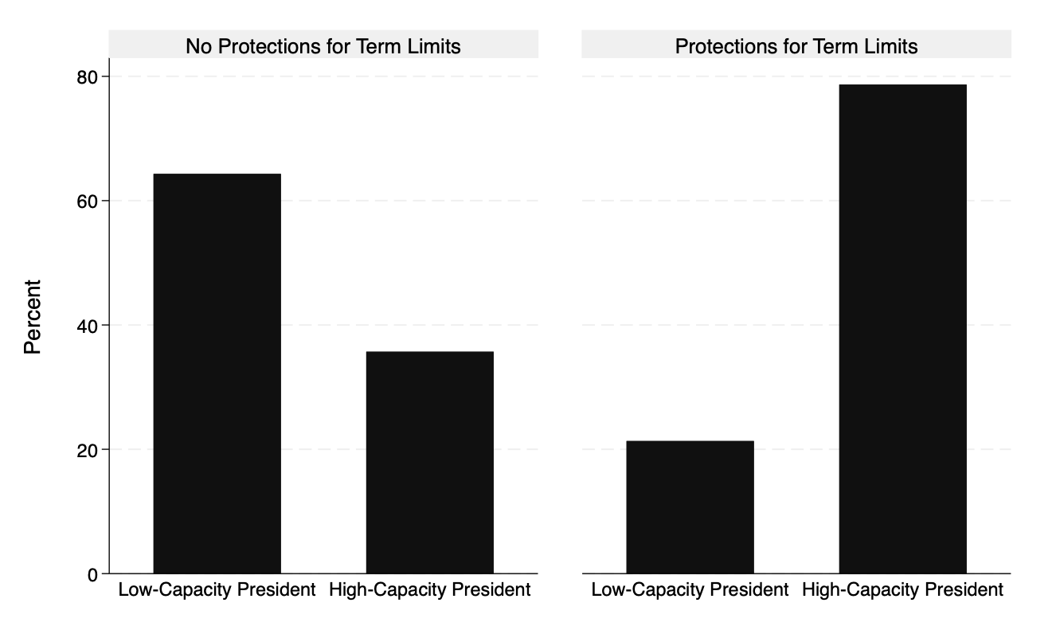

How Protections Work: Complicating Preferred Strategies
In short, I will argue that constitutions which declare term limits unamendable increase the costs presidents pay to alter term limits. I argue they are effective. This argument makes two assumptions. 1) Amendments are presidents’ preferred strategy because they allow for targeted, piecemeal change, and success is typically predictable based on partisan control of the legislature. If constitutions bar presidents from amending term limits, then presidents must rely on one of two other strategies: judicial reinterpretation via courts or constitutional replacement via citizen assemblies. 2) These alternative strategies are sub-optimal, in general. When presidents rely on courts or citizen assemblies to alter term limits, they face a dilemma. They can either accept the risk that the courts or assembly act against them, potentially rolling back their authority in other domains, or they can select loyalists to operate the court or assembly. Selecting loyalists often requires cross-branch political coordination, which is costly. If either of these assumptions are true, then unamendable protections increase the costs presidents pay to stay in power.
Presidents have three strategies to evade term limits: amend the term limit provision in the legislature, replace the constitution through citizen assemblies, or request that courts reinterpret the term limit provision. The most common strategy is to pass a legislative amendment. In Versteeg et al’s study of evasion attempts from 2000-2018, amendments accounted for 63% of all strategies. In my expanded version of their dataset from 1990-2023 capturing multiple attempts by the same presidents, amendments represented 70% of all attempts.
Presidents may select legislative amendments as their weapon of choice because amendments are more predictable than calling constitutional assemblies or asking courts to reinterpret the term limit provision. Presidents, especially popular presidents, are often able to muster the 2/3 or 3/4 majorities necessary to pass constitutional amendments, so the political barrier to amending term limits is often insufficient. In contrast, before relying on courts, presidents must be sure that the justices involved are willing to set aside commitments to the rule of law to help the president stay in power. In absence of these guarantees, presidents either take a risk with the current justices or attempt to pack the court to reduce uncertainty in justice decisions. The remaining alternative is constitutional conventions, where presidents face coordination problems: can presidents be sure that their precise goals will be reflected in constitutional change?
This is not to say that amendments do not have any disadvantages relative to other mechanisms of constitutional reform. For instance, because amendments are largely a legislative affair, they are more susceptible to public pressure than court decisions, suggesting that unpopular or weak presidents may prefer the latter either due to fear of legislative dissent or public backlash. Indeed, the publicity of loud legislative debates on term limit extension can spur violence, as Versteeg et al note. When Paraguayan President Horacio Cartes attempted to extend his term with an amendment in 2017, protesters set fire to the Congress building. A similar incident occurred in Burkina Faso in 2014. While President Blaise Compaore’s legislature was considering an amendment that would allow Compaore to serve an additional term, protesters met and set fire to the parliament building. In both cases, amendments to term limits ultimately failed. However, these should not be overstated as they rarely materialize.
By making amendments to term limits illegal, protection provisions force presidents to either accept higher risk or exert greater effort to ensure success. I argue relying on courts or citizen assemblies is sub-optimal for presidents, but that term limit protections do not necessarily raise these costs higher than they are to begin with. As a result, protections close off the easiest and most predictable option while leaving open two riskier routes.
First consider judicial reinterpretation. This strategy involves no actual changes to the language in the constitution, but rather term limits are watered down and stripped of their meaning. Recently, courts in Latin America have struck down term limit provisions altogether, reasoning that term limits violate presidents’ human rights to compete for and hold political office. When presidents rely on justices to reinterpret term limits, they can either take a gamble or pack the court. If president gamble, they risk that the current justices are more loyal to the rule of law than the president’s interests, and thus the justices may rule against the president. In this way, relying on the courts involves risk. However, to reduce this risk, presidents might call on their legislative allies to remove unfriendly justices and appoint new allies. Importantly, court packing requires coordination with legislators and may risk instability if the move is unpopular. In this way, relying on the courts is a sub-optimal strategy.
Although relying on courts is sub-optimal, unamendable protections probably do not make the strategy any less likely to succeed if it is attempted. Protections are unlikely to alter the incentives motivating justices, and, indeed, justices who are willing to reinterpret an unprotected term limit are probably willing to reinterpret a protected one. The decision reflects the ‘type’ of the justice: is this a justice who respects the rule of law, or will they set the law aside in service to the president? This explains why regardless of the presence of protected term limits, courts that issue reinterpretations of term limits have often been recently packed with loyalists. In sum, though presidents may reasonably choose not to seek help from courts when term limits are protected because the outcomes are uncertain and court-packing poses coordination problems, protections themselves do little to alter the chance this strategy succeeds if tried. The largest obstacle to presidents pursuing this strategy is ensuring a favorable outcome by guaranteeing that justices who are on the court are loyal to their interests.
Second, presidents may rely on constituent assemblies to circumvent term limits. As Elkins put it: “Do the limits serve to deter evasion, or do leaders simply replace the constitution instead of amending it, in which case the drafters’ resolution of ‘never again’ feels like last year’s New Year’s resolution?” Indeed, reasoning suggests protections for term limits should notalter the incentives of the public. If citizens are apt to rewrite their constitution, regardless of whether this is because they genuinely support the president or are afraid of state repression, the unamendable status of term limits is unlikely to change peoples’ minds. Consequently, the conventional wisdom suggests that the prospect of constitutional replacement renders term limit protections pointless.
Not so. Constitutional conventions amplify otherwise negligible uncertainty and risk in the process of constitutional reform. From the perspective of a sitting president, rewriting the constitution is a dangerous game. Even if a president manages to simultaneously maintain a veneer of legitimacy while hijacking a convention with loyalists, they may have little direct control over what is written, and the public response may be outside of the president’s control. Even a dictator like Robert Mugabe nearly lost control of an unwieldy convention that introduced presidential term limits for the first time in decades. (Mugabe himself was ultimately granted an exception). The convention also nearly introduced age limits which would have barred Mugabe from running again.
Constitution-making is inevitably risky because these inherently normative projects always convert agreed-upon facts (“the president is only allowed to serve two terms”) into politically salient questions (“how many terms should the president be able to serve?”). In 2016, when Bolivian voters were allowed to voice their opinion on populist Evo Morales’ proposal to loosen term limits, the result was a narrow (51%) “no.” Re-writing the constitution is a high-risk, high-reward strategy that enables changing multiple constitutional provisions at once, but if the convention acts inconsistent with presidential interests, they have a lot to lose. Perhaps as a result, conventions have often been initiated by “strongmen” presidents, like Egypt’s Abdel Fattah el-Sisi in 2019 and Chad’s Idriss Deby in 2018; both faced accusations that the process was insulated from the public and were not genuine democratic expressions of popular will. Strong-man presidents may be more confident they can leverage coercive pressure to reduce risk and secure their desired outcomes in a convention.
When less powerful presidents can avoid such risk, they do so, often preferring to keep the process of constitutional change firmly within legislatures where elites can be more easily cajoled and the public kept out. In these scenarios, presidents attempt piecemeal, targeted change through amendments without risking wholesale political change that could undermine their current authority. Most presidents should prefer to avoid relying on conventions to alter term limits, yet unamendable provisions tie their hands and force would-be “dictators for life” to make more difficult decisions than would be necessary otherwise. In sum, hardened term limits force presidents to play a high-risk game, resulting in a net-loss for all presidents except those who can afford to hold sham conventions or pack the court with partisans. To the extent this is true, amendments are a safer and cheaper choice for presidents, and closing off the path for amendments is valuable.
Importantly, if term limit protections cause presidents to expend more political capital or take more risks to alter term limits than they otherwise would, then these protections are effective even if presidents succeed at staying in power. The effectiveness of these protections lies in the avenues they close off and the additional costs and risks tagged on to already unattractive options. If implemented among a wider sample, it is likely that for some presidents, the additional costs could make the difference in changes to term limits succeeding or failing. Even in the sample where these provisions are active, there should be observable changes to presidential decision-making. The next section will rely on the global dataset introduced in this paper to look for evidence that protections alter how presidents attempt to prolong their time in office.

Presidential Decision-making Under Protected Term Limits
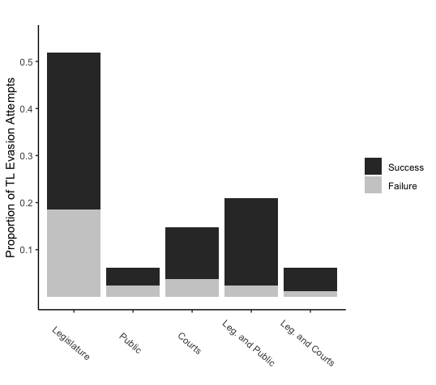
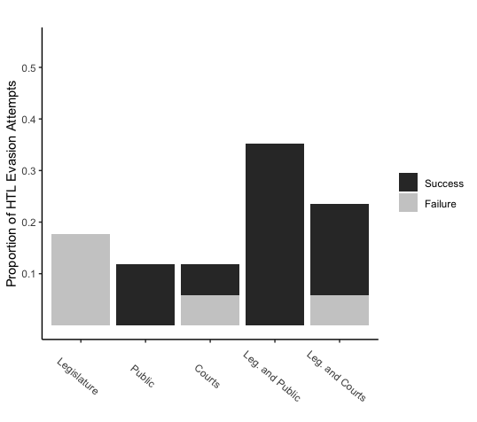
The argument for protected term limits is that they close off the easiest route for presidents committing term limit evasion and force presidents to rely on more than just their legislative cronies. Do presidents under protected term limits actually end up relying on different actors for support, and if so, which ones are most common? How do presidential strategies for term limit evasion shift under protected term limits?

Figures 6 and 7 illustrate the actors involved in term limit evasion attempts with and without protections for term limits. Under protected term limits, all attempts to alter term limits involving only legislatures have failed, and they predictably are far less common. Notably, attempts involving support from only courts or the public remain relatively uncommon under protections, but there is an increase in the proportion of cases involving a combination of legislative support and support from either the courts or the public. In these cases, the public or courts play the primary role in either rewriting the term limit provision or reinterpreting it, but the legislature plays a subsidiary role in legitimating the action.
The shift to strategies involving a combination of actors has important implications because it is by no means a necessary consequence of term limit protections. Why do presidents not rely on multiple actors when term limits are unprotected? There may be non-negligible costs to coordinating multiple actors and, in general, relying solely on the legislature is optimal. When this is not possible, presidents often find ways to engage the legislature in legitimating procedures aimed at bolstering the legality of the contentious proposal. Figures 6 and 7 show that unamendable term limits cut off the easy route, forcing presidents to ultimately rely on other actors to do the bulk of the work. Most importantly, the fact that combinations, particularly involving courts, are uncommon absent protections but very common with protections may suggest protections increase the amount of political capital or organizational capacity necessary for success.
Figure 7 may be the first to capture the global frequency of evasion strategies in countries with protected term limits. Consistent with our predictions, strategies involving the public are the most common, and they have a stunning 100% success rate, potentially indicating the extent of anticipation that occurs prior to the plan’s execution. This may be because the strong-men and popular presidents likely to engage the public to loosen term limits are often assured of the outcome ahead of time. Strategies involving courts have the second highest frequency and success rate, while strategies involving the legislature are rare and have never succeeded when protections are present.
In addition to different actors playing a central role, term limit evasion is often a more piecemeal process when term limits are protected. Scholars have noted that term limit evasion can occur in two forms: “hard” evasions seek to fully purge a term limit provision from the constitution, allowing indefinite overstay, while “soft” evasions merely alter the provision’s enforcement while still leaving some end-date in place. Examples of hard evasion include Xi Jinping in 2018 removing China’s term limit provision or Daniel Ortega’s judicial allies striking down Nicaragua’s term limit in 2009, while an example of soft evasion is Paul Kagame’s 2015 referendum approving a new constitution shortly before an upcoming election; the new constitution kept a maximum two term limit, but since Kagame had not held office under the new constitution, the referendum allowed him to again serve the maximum two terms. In general, evasions that keep term limits in-tact are 30% more common (p < 0.05) in countries where constitutions protect term limits from amendment. When protections are present, like in El Salvador or Honduras, it is extraordinarily rare to see term limits fully removed from the constitution; in contrast, in cases without protections like China under Xi Jinping, Nicaragua under Ortega, or Venezuela under Chavez, removal is more common.
This does not mean that evasion is innocuous so long as term limits are left in place. Many presidents have stayed in office for decades using repeated soft evasion strategies. Russia’s Vladimir Putin, for instance, has stayed in power over 20 years evading term limits 3 separate times while never removing them. Putin swapped places with his Prime Minister for one term before extending the presidential term from 4 to 6 years and then finally writing a new constitution in 2020 designating the following election as his first in the eyes of the country’s new constitution. The latter move effectively reset his number of terms served, and he is legally allowed to continue running for office until 2036. However, it is important to note that as long as term limits are active, they place pressure on presidents to act against them, and sometimes presidents’ capacity to keep making changes runs out. For instance, when the legislature in the Dominican Republic granted President Danilo Medina a second term in 2015, overriding a previous ban on reelection, Medina had won a small victory but would eventually be blocked from serving a third term without further action. When his supporters asked the court to allow for a third term, the court refused and Medina was forced to step down. Though more work is needed to determine how consequential this difference is, it is notable that presidents in cases where protections are present almost never successfully remove their term limits.

Honduras: Manuel Zelaya and Juan Orlando Hernandez
I now turn to a particular case to trace how protections for term limits affect presidential decision-making. Honduran Constitution boasts the second oldest protected term limit regime in the world, and it contains some of the strongest restrictions on term limit alteration. The protections are fourfold: a strictly worded single four-year term, punishment for attempts at term limit evasion, an unamendable provision, and an effective ban on constituent assemblies. First, Articles 237 and 239 establish a four-year term for the President and explicitly stipulate that “[t]he citizen who has fulfilled the holding of title of Executive Power cannot be President or Vice President of the Republic.” Second, Article 239 goes on to clarify that any attempt by a President to contravene the one-term rule results in a ban from holding public office: “Whoever breaks this provision or proposes its reform, as well as those who support him directly or indirectly, will immediately cease the performance of their respective offices and will be disenabled for ten years from the exercise of any public function.” Thirdly, Article 374 clarifies that the presidential term cannot be amended: “the Articles of the Constitution relating to the form of government, national territory, the presidential term, the prohibition from reelection to the presidency of the republic, the citizen who has served as president under any title, and persons who may or may not be president of the republic for the subsequent period cannot be amended.”
Fourthly, Article 375 effectively imposes a ban on constitutional replacement: “[T]his Constitution does not cease to be in effect nor does it cease to be in force by act of force or when it is allegedly repealed or amended by any means or procedure other than that which it itself provides.” As a result, the only legal way to alter the Constitution is by a 2/3 vote of two sequential sessions of Congress, if and only if the subject-matter is not listed as unamendable (Art 373). In addition, another punishment is specified for violating the ban on illegal methods of constitutional reform:
“Persons responsible for the events specified in the first part of the foregoing paragraph, as well as the principal officials of governments that may subsequently be organized, shall be tried in accordance with this Constitution . . . The Congress may . . . decree the forfeiture of all or part of the property of those persons and of others who have enriched themselves by supplanting the sovereignty of the people or by usurping the public powers . . .” (Art 375).
The Honduran Constitution is abundant in its protections for presidential term limits and explicit about the consequences for violating them. Strategically, the only options available to aspiring overstayers are to either rely on the courts to reinterpret the existing provisions. Presidents operating under these constraints should require significant political support from elites and coordination among various branches of government that could otherwise block an evasion attempt. Next, I examine the cases of Manuel Zelaya, who was removed in a 2009 military coup following allegations of attempted term limit evasion, and Juan Orlando Hernandez, who succeeded in effectively scrapping Honduras’ term limit provision only five years later. Throughout, my focus is twofold: 1. why did Hernandez succeed where Zelaya failed, and 2. what were the observable effects of Honduras’ protected term limit regime?

Manuel Zelaya: Facts of the Case
On March 23, 2009, President Manuel Zelaya of Honduras announced his intention to hold a nationwide vote on whether to convene a Constituent Assembly to draft a new constitution. Zelaya, along with center-left Liberal Party allies in Congress, won office in 2006, and his term was set to expire in January 2010. When Zelaya’s policies shifted further left, critics feared the president’s progressive policy agenda was placing Honduras on track with recent cases of democratic decline spearheaded by left-wing populists in Venezuela, Bolivia, and Ecuador, and they argued Zelaya would use the proposed Constituent Assembly to loosen term limits and extend his time in power just like conventions by Hugo Chavez and Evo Morales. While the ultimate purpose of Zelaya’s proposed Assembly remains disputed, critics’ fears of left-wing authoritarianism echoed within Honduras, in international media, and by US government officials.
Zelaya’s announcement of a poll to hold a constituent assembly faced swift condemnation from the Honduran Attorney General and the courts. On March 23, the same day as Zelaya’s announcement, Attorney General Luis Alberto Rubi said he was “convinced that neither the Constitution of the Republic nor the Electoral Law for Political Organizations give the Republic’s President the power to administer any referendum”; as a result, pursuant with Article 375, Rubi announced anyone who continued to participate in administering the referendum “will be the subject of a criminal investigation and the Public Ministry will present a case with the goal of having the competent judicial authority impose the punishment previously established by the Penal Code”. While Zelaya proceeded with plans for the referendum, by May a public confrontation unfolded between the President and the judicial branch. On May 27, a lower court issued an injunction halting the referendum, claiming it was “in clear violation of the Constitution of the republic and other laws.” When Zelaya declared that the referendum would proceed as a nonbinding poll, on May 29 the Court issued a second ruling stating that the prior order would apply to any executive decrees with the same goal.
The battle soon embroiled the military. The head of the armed forces, General Romeo Vasquez Velasquez announced the military would not go through with supporting the referendum, and Zelaya subsequently had the general removed. The Supreme Court of Justice quickly reinstated Vasquez. On June 25, three days before the election, Zelaya and supporters overran a military fort where the ballots for the upcoming referendum were being held. The same day, Attorney General Rubi announced four charges against Zelaya, and on June 26 the Supreme Cout of Justice issued an arrest warrant. On June 28, the day of the proposed referendum, the Honduran military arrested Zelaya, and the National Congress, still led by Zelaya’s own party, unanimously approved the official removal of the President, and replaced him with the head of Congress.

Why Zelaya Failed: Lack of Unified Support Among Elites
Why did Zelaya’s attempt at constitutional change fail? The forceful response seems particularly disproportionate given that Zelaya was not even proposing any explicit changes to the constitution; the proposed referendum was merely to call for a convention. But the legal decisions made by the Honduran courts and statements from Congress suggest that the Honduran constitution’s protections against change, which are rooted in preventing term limit evasion, played a pivotal and persuasive role in shaping the government response. The case illustrates how closing off routes of legal constitutional change reduces the options available to potential overstayers and increases opportunities for opposition to organize collectively against the president. In Zelaya’s case, a strong constitutional regime protecting term limits combined with significant suspicion from opponents and a unified opposition, including within his own party, resulted in not only a failed attempt at constitutional change but ultimately his own removal.
Honduran officials questioning the legality of Zelaya’s proposal made frequent and clear reference to the Constitution’s articles preventing amendments to term limits and wholesale constitutional change. The Attorney General’s statements in late March 2009 warned “all public officials” of the consequences of “participation in acts … aimed at carrying out the consultation that involves reforming or repealing the Constitution in open rebellion against the provisions of Articles 5 and 374 contained in the text of the Fundamental Law of the Republic.” Later, legal documents justifying Zelaya’s removal were posted on the official website of the Judicial branch. The documents included statements by the Attorney General accusing Zelaya of violating articles 373, 374, and 375: “in calling for a National Constituent Assembly, it is evident that the intention is to repeal the current Constitution, an action constituting the crime that concerns us regarding the provisions of articles 373, 374, and 375 of our Constitution.” The same statement concludes, “[Zelaya’s] conduct qualifies as a crime of abuse of authority, usurpation of functions, [and] treason to the country . . .” The attorney general clearly invoked the protections for term limits imbedded in the Honduran Constitution; had these protections been absent, it is hard to imagine the same legal reasoning being persuasive.
Many elites opposing Zelaya believed that the referendum was illegal, and this belief created a rallying point for a unified opposition. When the Organization of American States sent election observers specifically for Zelaya’s proposed referendum, Congress voted unanimously to ask them to leave because they were legitimizing an illegal vote. The military, too, went along without protest when the court declared the referendum illegal. Moreover, when Zelaya removed General Velasquez, heads of the army, navy, and air force resigned to show their support, and members of Congress praised Velasquez as a national hero. The Supreme Electoral Tribunal announced the same day that the referendum was illegal. These actions, all taken just days before the military coup, were clear signals to Zelaya, and more importantly to his opponents, that there was a coordinated opposition that spanned the legislative and judicial branches, the military, and electoral officials. The president no longer had the support necessary to stay in power, much less to enact constitutional change.
As Table 4 illustrates, Zelaya had several factors working against him. McKie (2019) argued that presidents who come to power in competitive electoral contexts are more likely to fail at term limit evasion, and Corrales (2016) found that high presidential approval ratings are often associated (more than difference in legislative seat share) with successful evasion attempts. Zelaya’s electoral context was competitive (as defined by McKie), and his net approval rating was negative, both inauspicious signs. While his party did control the legislature by a narrow margin, which Negretto (2022) finds important, as this case study shows, Zelaya’s own party actively worked against him during his attempt at term limit evasion; a better predictor of success may be how well presidents actively rally their allies rather than just legislative party control itself. Particularly in the context of Honduras’ strong protections for term limits, where would-be overstayers are forced to choose sub-optimal strategies requiring greater risk or coordination, Zelaya could not succeed at altering his term limits.

Juan Orlando Hernandez: Facts of the Case
Juan Orlando Hernandez became President of Honduras in 2014 after winning the National Party’s nomination under suspicious circumstances in 2012. In the National Party’s primary, Hernandez’s opponent, Ricardo Alvarez, suspected fraud and requested a recount. While the Constitutional Chamber of the Supreme Court was considering the appeal, Congress, controlled by Hernandez’ National Party and presided over by Hernandez himself, replaced 4 out of the 5 judges on the Court with loyalists. The move was illegal, as Congress had no power at the time to remove justices. The new Court denied Alvarez’ request for a recount claiming there was no basis for fraud, and Hernandez became the National Party’s nominee. Regardless of the veracity of the fraud claims, the replacement of justices on the Supreme Court clearly demonstrated and strengthened Hernandez’ power within the Honduran government before he ever held the Presidency.
In 2015, the Honduran Supreme Court struck down Honduras’ one-term maximum (Article 239) “for restricting, diminishing and distorting fundamental rights and guarantees established in the Constitution itself and in the treaties on Human Rights signed by Honduras before the entry into force of the Constitution of 1982 . . .” The justices argued that the presidential term limit violated citizens’ human rights to seek and hold political office, a popular line of reasoning that has been strongly condemned by international lawyers and human rights organizations. The Court largely disregarded the Constitution’s protections for term limits, only briefly discussing Articles 373 (legal procedures for amendment) and 374 (ban on amending term limits) to frame them as posing a “dilemma” for resolving “a current problem originating with the strict application of rules. . .” Ultimately, the court ruled the unamendable provision was inapplicable, along with the term limit itself.

Why Hernandez Succeeded
Why did Hernandez succeed where Zelaya failed? What factors played the most important role, and did protections for term limits matter at all? From first glance, one might conclude Hernandez’ successful contravention implies Honduras’ term limit regime and protections were weak, but this overlooks the amount of power Hernandez accrued by the time of the court decision and the highly contingent nature of term limit modification in Honduras. In sharp contrast to Zelaya, Hernandez was unchallenged by his allies in the legislature, courts, and military. Hernandez installed strong allies where Zelaya had made powerful enemies. Critically, judicial reinterpretation was the only legal avenue for Hernandez to prolong his time in power, thanks to the Honduran Constitution’s strict restrictions. Zelaya and Hernandez operated under the same structural restrictions; the constitutional language strictly prohibiting presidential reelection did not change, and neither did the explicit punishments for term limit evasion. The difference is the Hernandez was able to coordinate unified support among allies to fill the court with justices that would disregard restraints, while Zelaya’s illegal attempt to replace the constitution created a rallying point for opposition to depose him. Hernandez’ success does not diminish Honduras’ term limit protections but underscores the control and unified support he had in 2015. The two Honduran cases illustrate both the possibilities and upper limit of efficacy for protected term limits.
The contrasts between Zelaya and Hernandez are stark. Hernandez often benefited from energetic allies in the same sectors of government that strongly opposed Zelaya during his bid for a convention. While Zelaya’s attorney general prosecuted the President with charges of treason, Hernandez had illegally installed a loyalist to the position. When there was a vacancy for attorney general in 2013, the appointee should have been legally restricted to finishing the term and stepping down, but Hernandez’ allies in Congress approved the pro-government Oscar Chinchilla, the single Supreme Court Justice who survived the 2012 purge, to be attorney general for a new five-year term. While military opposition de facto prevented Zelaya from carrying out his executive decrees, Hernandez militarized and expanded the police force, which was often accused of intimidation and violence against critics and political opponents. Most importantly, while Zelaya frequently found himself at odds with Congresspeople from his own party, often suspicious of his close ties with Venezuelan President Hugo Chavez, Hernandez’ allies in Congress went to bat installing loyalists on the Supreme Court, the only actor that could even legally attempt to grant Hernandez a second term. And while Zelaya’s Supreme Court legitimated the 2009 coup, Hernandez’ cronies struck down his term limit provision.

Table 4: Predictions of Manuel Zelaya’s Evasion Outcome
Predictor | Zelaya | Zelaya Prediction | Hernandez | Hernandez Prediction
Difference Between Seat Share of President’s Party & Opposition Party (Negretto 2022) | +4% | Minor benefit | +6% | Minor benefit
Competitive, Less Competitive, or Non-competitive Elections (McKie 2019) | Competitive | Failed attempt | Competitive | Failed attempt
President’s Net Approval Rating (Corrales 2016) | -22% | Failed attempt | +32% | Successful attempt
Coordination Among Elites (this paper) | Unified Opposition | Failed attempt | Unified Support | Successful attempt

Discussion
Constitutional designers have incentivized term limit compliance by introducing articles that make term limits unamendable or strongly protected. These provisions have been common in the presidential systems of Latin America and Africa, and they frequently appear in countries where term limit evasion has historically been problematic. For scholars hoping to evaluate efficacy, there are many challenges. Rather than examining the effects of protections on presidential decision-making, work has often compared compliance across cases of protected and unprotected limits, ignoring the confounding effect of presidential strength. I have argued protections for term limits work by forcing presidents to choose costlier strategies to alter term limits, and that for some presidents who do not currently have protected term limits, these additional costs would be too much to bear.
Unamendable term limits complicate term limit evasion by restricting the decisions available to a president hoping to alter their maximum tenure. Rather than simply amending away the expiration dates of their rule, like the overwhelming majority of successful overstayers, these presidents must find another way to stay in power. Often, this occurs through constitutional replacement and, less frequently, through judicial intervention. Both are more costly to presidents than simply relying on a legislature to amend the constitution. Constitutional conventions led by citizenry introduce elements of uncertainty as citizens may both empower the president and enact new restrictions. Relying on unelected judges requires confidence that the judges are loyal to the president’s interests.
The global dataset on protected term limit evasion has shown that presidents with protected term limits often rely on different evasion strategies. While the legislature by far plays the dominant role in evasions where there are no protections for term limits, the public and courts are more active in cases with protections, and these strategies are often supplemented by legislative decrees or appointments aimed at improving the odds of success. Moreover, presidents with protections are far less likely to succeed at removing their term limits and were much more likely to rely on strategies that in some way kept term limits in-tact. Contrasting the stark difference in outcomes between Manuel Zelaya and Juan Orlando Hernandez in Honduras highlights the crucial role of widespread elite support in overcoming protected term limits. While Zelaya’s proposed assembly faced unified opposition from the legislature, courts, and military who frequently made reference to Honduras’ longstanding term limit protections, Hernandez’s legislative allies placed partisan justices on the supreme court that would go on to nullify his term limit. The case illustrates both the potential and the limitations of protections if tried among a wider sample.
Given the downstream effects protections can have on presidential decision-making, should they be adopted more broadly? On the one hand, some may worry that forcing presidents to rely on methods of wholesale constitutional change to alter term limits may encourage a faster deconstruction of checks and balances. After all, if a president and their supporters go through the trouble of replacing the constitution, why stop at changing term limits? A 2019 referendum in Egypt extended President Abdel Fattah al-Sisi’s maximum tenure, but it also expanded his control over the legislature by empowering him to select a third of the members of a new chamber; it simultaneously reduced the power of the lower house and made it easier for the President to pack the high court. By closing off the easy route, some may worry that protections quicken democratic decline by encouraging presidents to gamble on strategies that are higher risk but higher reward.
However, these concerns may be unjustified. Presidents seeking to expand their power through constitutional change will alter as much as they believe they can get away with safely, regardless of whether the constitution has protections in place for term limits. While protections may force presidents to rely more heavily on constitutional replacement as a method for altering term limits, their odds of successfully doing so are not heightened from protections being in place. If a would-be autocrat is capable of dismantling multiple checks on their power at once, they will do so even in the absence of term limit protections. Consider Hugo Chavez’ decision to completely alter the constitutional order in Venezuela, which did not have term limit protections. Chavez’ constituent assembly reflected both Chavez’ desire to drastically expand his power and his confidence that he could successfully do so. Had protections been in place, it seems unlikely that this would have made him even more apt to rewrite the constitution. The choice of constitutional replacement reflects a president’s confidence that they can get the wide range of changes they want passed.
Future research on term limit evasion should consider the presence or absence of term limit protection clauses as an important contributing factor explaining presidents’ strategies. Scholars should be attentive to the strong relationship between powerful presidents and stronger constitutional protections for term limits which confounds simple tests of efficacy. Lastly, future research may explore the history of these provisions: what considerations led to their early adoption in Latin America, and how did they spread from their places of origin?

Data Availability Link to repository with replication data and code available at later stage; all data available on request
Competing Interests I have no competing interests to declare

Bibliography

Amnesty International. “Honduras: Exercising the right to protest has a high cost for those who dare take to the streets.” (2019). https://www.amnesty.org/en/latest/press-release/2019/07/honduras-ejercer-derecho-protesta-tiene-alto-costo/
Albert, Richards. “The Three Varieties of Unamendability” In: Constitutional Amendments: Making, Breaking, and Changing Constitutions. (2019). Oxford University Press. doi: 10.1093/oso/9780190640484.003.0005.
Araya, Ignacio Arana. “Dominant Personality and Politically Inexperienced Presidents Challenge Term Limits.” The Journal of Politics, January 24, 2023, 723988. https://doi.org/10.1086/723988.
BBC. “Burkina Faso Parliament Set Ablaze.” (2014). https://www.bbc.com/news/world-africa-29831262
BBC, “Egypt President Could Rule Until 2030 as Constitutional Changes Backed.” (2019). https://www.bbc.com/news/world-middle-east-48035512
Bermeo, Nancy. “On Democratic Backsliding.” Journal of Democracy 27, no. 1 (2016): 5–19. https://doi.org/10.1353/jod.2016.0012.
Brewer-Carias, Allan. “Venezuela 2009 Referendum on Continuous Reelection: Constitutional Implications.” Paper presented at the Americas Society/Council of the Americas in New York. 2009. https://academiccommons.columbia.edu/doi/10.7916/D84J0S9B/download;
Cayman Compass. “Hondurans Face Referendum Conundrum.” (2009). https://www.caymancompass.com/2009/06/26/hondurans-face-referendum-conundrum/
Corrales, Javier. “Can Anyone Stop the President? Power Asymmetries and Term Limits in Latin America, 1984–2016.” Latin American Politics and Society 58, no. 2 (2016): 3–25. https://doi.org/10.1111/j.1548-2456.2016.00308.x.
Coppedge, Michael et al, “V-Dem Codebook v12 Varieties of Democracy (V-Dem) Project.” (2022)
CNN International. “Honduras President Challenges Government over Referendum.” (2009). http://web.archive.org/web/20090802090932/http://edition.cnn.com/2009/WORLD/americas/06/25/honduras.general/index.html
Diamond, Larry. “The Democratic Rollback: The Resurgence of the Predatory State.” Foreign Affairs 87, no. 2 (2008): 36–48.
Dixon, Rosalind, and David Landau. “Constitutional End Games: Making Presidential Term Limits Stick.” Hastings Law Journal 71 (2020).
EEAS, “Statement by the Spokesperson on the New Constitution in Chad.” (2018). https://www.eeas.europa.eu/node/44050_en
Elkins, Zachary. “Effects of a Hard Commitment to Alternation in Power.” Texas International Law Journal 57, no. 3 (2022): 381–96.
Elkins, Zachary. “Term-Limit Evasions and the Non-Compliance Cycle.” Constitutional Political Economy 32, no. 3 (September 2021): 326–45. https://doi.org/10.1007/s10602-021-09332-y.
El Heraldo. “Sala Constitucional declara inadmissible conteo voto por voto.” (2013). Archived at https://web.archive.org/web/20130126093727/https://www.elheraldo.hn/Secciones-Principales/Pais/Sala-Constitucional-declara-inadmisible-conteo-voto-por-voto
El Heraldo, “La presidenta Xiomara Castro no decidio buscar la reelecion en 2025.” (2024). https://www.elheraldo.hn/elheraldoplus/factchecking/presidenta-xiomara-castro-no-busca-reeleccion-2025-honduras-video-PC17519622
Frank, Dana. The Long Honduran Night. Chicago IL: Haymarket Books, 2018.
Giraldo, Camilo. "Honduras Poll Indicates Support for New President's Iron First Policies." Insight Crime. (2014). 32, no. 4 (2021): 27–41. https://insightcrimedoi.org/news/brief/honduras-poll-indicates-support-for-new-presidents-iron-fist-policies/

Ginsburg, Tom, James Melton, and Zachary Elkins. “On the Evasion of Executive Term Limits.” William and Mary Law Review 52 (2011): 68.
Greensberg Quinlan Rosner Research. "Honduras Frequency Questionnaire." (2009). Archived at https://web.archive.org/web/20091122092618/http://www.gqrr.com/repository/documents/1574.pdf10.1353/jod.2021.0050.
Heyl, Charlotte, and Mariana Llanos. “Contested, Violated but Persistent: Presidential Term Limits in Latin America and Sub-Saharan Africa.” Democratization 29, no. 1 (January 2, 2022): 1–17. https://doi.org/10.1080/13510347.2021.1997991.
Landau, David. “Honduras: Term Limits Drama 2.0 – how the Supreme Court declared the Constitution Unconstitutional.” ConstitutionNet. (2015). https://constitutionnet.org/news/honduras-term-limits-drama-20-how-supreme-court-declared-constitution-unconstitutional
Landau, David, and Rosalind Dixon. “Designing and Protecting Presidential Term Limits.” In Comparative Election Law. Elgar, 2022.
———. “Tiered Constitutional Design.” George Washington Law Review 86, no. 2 (2018). https://ir.law.fsu.edu/articles/546.
Landau, David, Yaniv Roznai, and Rosalind Dixon. “Term Limits and the Unconstitutional Constitutional Amendment Doctrine: Lessons from Latin America.” In The Politics of Presidential Term Limits, by David Landau, Yaniv Roznai, and Rosalind Dixon, 53–74. Oxford University Press, 2019. https://doi.org/10.1093/oso/9780198837404.003.0004.
La Prensa, “Honduras: Fisacalia desautoriza llamado a consulta popular.” (2009). https://web.archive.org/web/20090327192109/http://www.laprensa.hn/index.php/Pa%C3%ADs/Ediciones/2009/03/26/Noticias/Honduras-Fiscalia-desautoriza-llamado-a-consulta-popular

Lueders, Hans, and Ellen Lust. “Multiple Measurements, Elusive Agreement, and Unstable Outcomes in the Study of Regime Change.” The Journal of Politics 80, no. 2 (April 2018): 736–41. https://doi.org/10.1086/696864.
Maltz, Gideon. “The Case for Presidential Term Limits.” Journal of Democracy 18, no. 1 (2007): 128–42. https://doi.org/10.1353/jod.2007.0010.
McKie, Kristin. “Presidential Term Limit Contravention: Abolish, Extend, Fail, or Respect?” Comparative Political Studies 52, no. 10 (September 2019): 1500–1534. https://doi.org/10.1177/0010414019830737.
Negretto, Gabriel L. “Tinkering with Executive Term Limits: Partisan Imbalances and Institutional Legacies in Latin America.” Democratization 29, no. 1 (January 2, 2022): 38–56. https://doi.org/10.1080/13510347.2021.1980539.
Organization of American States. “Statement by the OAS General Secretariat on the Elections in Honduras.” (2017). https://www.oas.org/en/media_center/press_release.asp?sCodigo=E-092/17
Poder Judicial de Honduras. "Expediente Judicial Relacion Documentada Caso Zelaya Rosales." Archived at https://web.archive.org/web/20100715200858/http:/www.poderjudicial.gob.hn/NR/rdonlyres/FB12D38C-64BE-433A-A648-1D416F57623A/4559/CasoJos%C3%A9ManuelZelayaRosales2.pps#256,1,Diapositiva%201
Poder Judicial de Honduras. "Ruling of the Constitutional Court on Appeals Filed on the Inapplicability of Article 239 of the Constitution of the Republic." Archived at https://web.archive.org/web/20220203004117/http://www.poderjudicial.gob.hn/Documents/FalloSCONS23042015.pdf
Roznai, Yaniv. “Unconstitutional Constitutional Amendments—The Migration and Success of a Constitutional Idea.” American Journal of Comparative Law 61, no. 3 (July 1, 2013): 657–719. https://doi.org/10.5131/AJCL.2012.0027.
Slotkin, Jason. “One Dead, Legislature Scorched After Violent Protests in Paraguay.” NPR. (2017). https://www.npr.org/sections/thetwo-way/2017/04/01/522314616/one-dead-legislature-scorched-after-violent-protestsin-paraguay
The Carter Center. “Constitutional Crisis in Honduras: An Expert Q&A.” (2009). https://www.cartercenter.org/news/current_qa/honduras_071309.html
Versteeg, Mila, Timothy Horley, Anne Meng, Mauricio Guim, and Marilyn Guirguis. “The Law and Politics of Presidential Term Limit Evasion.” Columbia Law Review 120, no. 1 (2020): 173–248.


Figure 1: Term Limit Evasion Attempts 1990-2023


Figure 2: Countries with a History of Protected Term Limits 1789-2023

Table 1: Protected Term Limits 1789-2023

Country | Type of Protection | Start | End | Years | Protections Introduced By | Protections Removed By
Algeria | Prohibits Amendment | 2020 | —— | 3 | New Constitution
Brazil | Special Procedure | 1934 | 1937 | 3 | New Constitution | New Constitution
Burkina Faso | Prohibits Amendment | 2014 | —— | 9 | Amendment
Central African Rep | Prohibits Amendment | 1981 | 1994 | 13 | New Constitution | New Constitution
Central African Rep | Prohibits Amendment | 2004 | —— | 19 | New Constitution
Colombia | Prohibits Amendment | 1840 | 1843 | 3 | Amendment | New Constitution
Congo | Prohibits Amendment | 1992 | 2015 | 23 | New Constitution | New Constitution
Cote d’Ivoire | Special Procedure | 2000 | 2016 | 16 | New Constitution | New Constitution
Cuba | Special Procedure | 2019 | —— | 4 | New Constitution
Dem. Rep. of Congo | Prohibits Amendment | 2005 | —— | 18 | New Constitution
Dominican Republic | Presidency Must be “alternative” | 1866 | 1868 | 2 | New Constitution | New Constitution
Dominican Republic | Only Permits Prospective Changes | 1878 | 1907 | 29 | New Constitution | New Constitution
Dominican Republic | Only Permits Prospective Changes | 1908 | 1927 | 19 | New Constitution | New Constitution
Ecuador | Presidency Must be “alternative” | 1851 | 1852 | 1 | New Constitution | New Constitution
Ecuador | Presidency Must be “alternative” | 1869 | 1878 | 9 | New Constitution | New Constitution
Egypt | Amendment to Term Limits Allowed Only if it “brings more guarantees” | 2019 | —— | 4 | Amendment
El Salvador | Prohibits Amendment | 1886 | 1948 | 62 | New Constitution | Amendment
El Salvador | Prohibits Amendment | 1983 | —— | 40 | New Constitution
Gambia | Special Procedure | 2019 | —— | 4 | New Constitution
Georgia | Presidency Must be “alternative” | 1992 | 1995 | 3 | New Constitution | New Constitution
Ghana | Special Procedure | 1969 | 1981 | 12 | New Constitution | New Constitution
Ghana | Special Procedure | 1992 | —— | 31 | New Constitution
Guatemala | Prohibits Amendment | 1945 | 1954 | 9 | New Constitution | New Constitution
Guatemala | Special Procedure | 1956 | 1982 | 26 | New Constitution | New Constitution
Guatemala | Prohibits Amendment | 1985 | —— | 38 | New Constitution
Guinea | Prohibits Amendment | 2010 | —— | 13 | New Constitution
Haiti | Only Permits Prospective Changes | 1987 | —— | 36 | New Constitution
Honduras | Prohibits Amendment | 1957 | —— | 66 | New Constitution
Madagascar | Prohibits Amendment | 2010 | —— | 13 | New Constitution
Mauritania | Prohibits Amendment | 2006 | —— | 17 | Amendment
Nicaragua | Only Permits Prospective Changes | 1893 | 1905 | 12 | New Constitution | New Constitution
Niger | Prohibits Amendment | 1999 | 2009 | 10 | New Constitution | New Constitution
Niger | Prohibits Amendment | 2010 | —— | 13 | New Constitution
Peru | Prohibits Amendment | 1933 | 1979 | 46 | New Constitution | New Constitution
Rwanda | Special Procedure | 2003 | —— | 20 | New Constitution
Senegal | Special Procedure | 2001 | —— | 22 | New Constitution
Togo | Special Procedure | 2019 | —— | 4 | Amendment
Tunisia | Prohibits Amendment | 2014 | —— | 9 | New Constitution


Figure 3: Types of Constitutional Protections for Term Limits, 1789-2023
Table 2: Types of Constitutional Protections for Term Limits, 1789-2023

Type | Subtype | Freq | Ex Citation | Ex Language
Prohibits Amendments | Protects the Idea of Term Limits | 11 | El Salvador 1983 Art 248 | “Under no circumstances, may the articles of this Constitution, which refer to . . . the principle that a President cannot succeed himself, be amended.”
 | Protects Term Limit Articles | 6 | Niger 2010 Art 175 | “. . . [t]he provisions of paragraphs 1 and 2 of Article 47 [term limit] . . . of this Constitution may not be made the object of any revision.”
 | Protects the Idea & Articles | 3 | Guatemala 1985 Art 281 | “In no case may Articles . . . 187 [term limit] be reformed, nor may any question concerning the republican form of government, or to the principle of the non-reelection for the exercise of the presidency of the Republic, be raised in any form, neither may the effectiveness or application of the Articles that provide for alternating tenure of the Presidency of the Republic be suspended or their content changed or modified in any other way.”
Special Procedure for Amending Term Limit |  | 10 | Rwanda 2015 Art 175 | “. . . However, if the amendment concerns the term of the office of the President of the Republic . . . the amendment must be passed by referendum, after adoption by each Chamber of Parliament.”
Only Permits Prospective Changes |  | 4 | Haiti 1987 Art 284 | “The amendment passed may enter into effect only after installation of the next elected President. In no case may the President under the Government that approved the amendment benefit from any advantages deriving there from.”
Presidency Must Be “Alternative” |  | 4 | Dominican Republic 1866 Art 103 | “Congress’ power to reform the Constitution does not extend to the form of government, which will always be republican, democratic, alternative, and responsible.”
Amendment Must Bring More Guarantees |  | 1 | Egypt 2019 Art 226 | “In all cases, texts pertaining to the re-election of the president of the republic . . . may not be amended, unless the amendment brings more guarantees.”

Table 3: Presidential Strength & Protected Term Limits
 | No Protections for Term Limits | Protections for Term Limits
Presidents rarely or never violate the Constitution (Low-Capacity) | 236 | 16 | 252
Presidents violate Constitution whenever they want, can violate most provisions without consequence, or some provisions without consequence (High-Capacity) | 131 | 59 | 190
 | 367 | 75 | 442


Figure 4: Theoretical Effect of Hardened Term Limits for High-Capacity vs Low-Capacity Presidents


Figure 5: Term Limit Protections More Likely for High-Capacity Presidents


Figure 7: Strategies in Evading Protected Term Limits

Figure 6: Strategies in Evading Unprotected Term Limits

Table 4: Predictions of Manuel Zelaya’s Evasion Outcome
Predictor | Zelaya | Zelaya Prediction | Hernandez | Hernandez Prediction
Difference Between Seat Share of President’s Party & Opposition Party (Negretto 2022) | +4% | Minor benefit | +6% | Minor benefit
Competitive, Less Competitive, or Non-competitive Elections (McKie 2019) | Competitive | Failed attempt | Competitive | Failed attempt
President’s Net Approval Rating (Corrales 2016) | -22% | Failed attempt | +32% | Successful attempt
Coordination Among Elites (this paper) | Unified Opposition | Failed attempt | Unified Support | Successful attempt

Parliamentary systems rarely employ term limits, so this study only concerns itself with presidents rather than prime ministers. For an examination of the origins of presidential term limits, and normative considerations, see Ginsburg, Tom, James Melton, and Zachary Elkins. “On the Evasion of Executive Term Limits.”
Calculated for all presidents from 1990-2023 using the Comparative Constitution’s Projects “HOSTERML” variable and defining democracies as having a V-DEM Polyarchy > 0.5.
Charlotte Heyl and Mariana Llanos, “Contested, Violated but Persistent: Presidential Term Limits in Latin America and Sub-Saharan Africa”
I calculated all statistics on term limit evasion using an expanded version of Versteeg et al (2020). For more information, see the data section.
Elkins, Zachary. “Effects of a Hard Commitment to Alternation in Power.”
Landau, David, and Rosalind Dixon. “Designing and Protecting Presidential Term Limits.”
Yaniv Roznai, “Unconstitutional Constitutional Amendments—The Migration and Success of a Constitutional Idea”
David Landau, Yaniv Roznai, and Rosalind Dixon, “Term Limits and the Unconstitutional Constitutional Amendment Doctrine: Lessons from Latin America”; Zachary Elkins, “Term-Limit Evasions and the Non-Compliance Cycle”; Elkins, “Effects of a Hard Commitment to Alternation in Power.”
Elkins, “Effects of a Hard Commitment to Alternation in Power.” Elkins count relies on the Comparative Constitutions Project’s (CCP) designation of constitutions with ‘unamendable provisions.’ However, I discovered that the CCP’s classification both undercounts instances of unamendable provisions and does not detect what Landau and Dixon call “tiered constitutional design,” where term limits may have higher standards for amendment but are not strictly excluded from amendment. I used the CCP’s list of all unamendable provisions as a starting point and read through hundreds of national constitutions individually, even if they were only listed as having a recent unamendable provision. I include cases where term limits are, technically, amendable but require special procedures to change.
For scholars interpreting alternation’s relationship to term limits, see Brewer-Carias, Allan. “Venezuela 2009 Referendum on Continuous Reelection: Constitutional Implications.”; Landau, Roznai, and Dixon, “Term Limits and the Unconstitutional Constitutional Amendment Doctrine.”
Mila Versteeg et al., “The Law and Politics of Presidential Term Limit Evasion”
Hans Lueders and Ellen Lust, “Multiple Measurements, Elusive Agreement, and Unstable Outcomes in the Study of Regime Change”
Michael Coppedge et al, “V-Dem Codebook v12 Varieties of Democracy (V-Dem) Project.”
For an example of earlier data on term limit evasion in the 20th century, see Araya, Ignacio Arana. “Dominant Personality and Politically Inexperienced Presidents Challenge Term Limits.” The Journal of Politics, January 24, 2023. https://doi.org/10.1086/723988
Versteeg et al., “The Law and Politics of Presidential Term Limit Evasion.”
Versteeg et al.
Jason Slotkin, “One Dead, Legislature Scorched After Violent Protests in Paraguay.”
BBC, “Burkina Faso Parliament Set Ablaze.”
Landau, Roznai, and Dixon, “Term Limits and the Unconstitutional Constitutional Amendment Doctrine.”
Elkins, “Effects of a Hard Commitment to Alternation in Power.”
EEAS, “Statement by the Spokesperson on the New Constitution in Chad;” BBC, “Egypt President Could Rule Until 2030 as Constitutional Changes Backed”
Gideon Maltz, “The Case for Presidential Term Limits,” Journal of Democracy 18, no. 1 (2007): 128–42, https://doi.org/10.1353/jod.2007.0010.
La Prensa, “Honduras: Fisacalia desautoriza llamado a consulta popular.”
La Prensa, “Honduras: Fisacalia desautoriza llamado a consulta popular.”
Poder Judicial de Honduras. “Expediente Judicial Relacion Documentada Caso Zelaya Rosales.” 11.
CNN International, “Honduras President Challenges Government over Referendum.”
The Carter Center, “Constitutional Crisis in Honduras: An Expert Q&A.”
La Prensa, “Honduras: Fisacalia Desautoriza llamado a consulta popular.”
Poder Judicial de Honduras, “Expediente Judicial Relacion Documentada Caso Zelaya Rosales.” 43.
Poder Judicial de Honduras, “Expediente Judicial Relacation Documentada Caso Zelaya Rosales.” 47.
Cayman Compass, “Hondurans Face Referendum Conundrum.”
CNN International, “Honduras President Challenges Government over Referendum.”
Kristin McKie, “Presidential Term Limit Contravention: Abolish, Extend, Fail, or Respect?”; Javier Corrales, “Can Anyone Stop the President? Power Asymmetries and Term Limits in Latin America, 1984–2016”
McKie (2019) classifies electoral contexts as competitive if the Margin of Victory for the President’s party in the past three legislative elections was ever less than 10%.
Gabriel L. Negretto, “Tinkering with Executive Term Limits: Partisan Imbalances and Institutional Legacies in Latin America”
El Heraldo, “Sala Constitucional declara inadmissible conteo voto por voto.”
David Landau, “Honduras: Term Limits Drama 2.0 – how the Supreme Court declared the Constitution Unconstitutional.”
Poder Judicial de Honduras, "Ruling of the Constitutional Court on Appeals Filed on the Inapplicability of Article 239 of the Constitution of the Republic."
Landau, Roznai, and Dixon, “Term Limits and the Unconstitutional Constitutional Amendment Doctrine” 68.
Poder Judicial de Honduras, "Ruling of the Constitutional Court on Appeals Filed on the Inapplicability of Article 239 of the Constitution of the Republic."
Dana Frank, The Long Honduran Night. 148.
Dana Frank, The Long Honduran Night. 179-180; Amnesty International. “Honduras: Exercising the right to protest has a high cost for those who dare take to the streets.”
Greensberg Quinlan Rosner Research. "Honduras Frequency Questionnaire."
Giraldo, Camilo. "Honduras Poll Indicates Support for New President's Iron First Policies."
Greensberg Quinlan Rosner Research. "Honduras Frequency Questionnaire."
Giraldo, Camilo. "Honduras Poll Indicates Support for New President's Iron First Policies."

